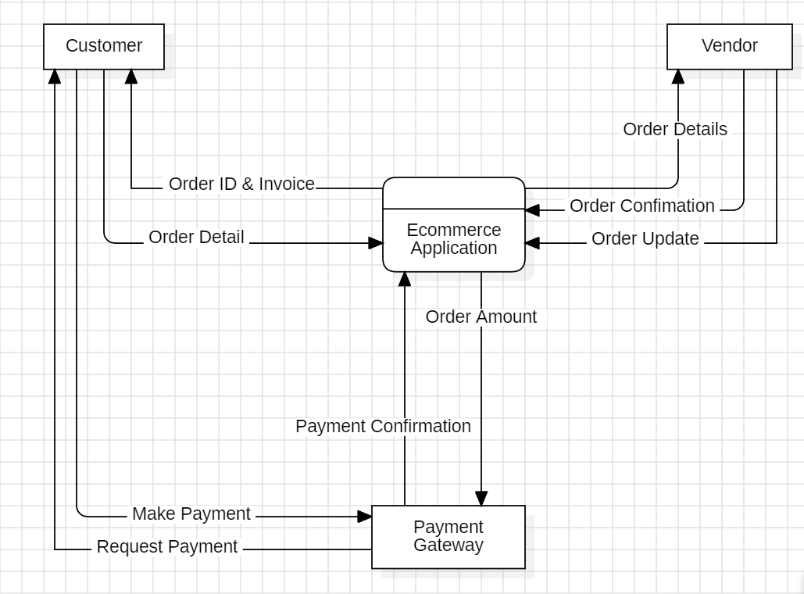

|  |
| --- |
| Fig: Data Flow Diagram Level 0 (Ecommerce Application) |